13 GEOGRAPHICAL FEATURES OF CANADA
broader view: (un)healthy lifestyles

Canada is the second largest country in the world after Russia and before USA. The total area of Canada is 9,970,610 km2. Of this, 9,215,430 km2 is land and 755,180 km2 is fresh water. Canada has only one border state - USA. Other frontiers are made by Arctic, Atlantic and Pacific ocean. This country extends 4627 km from the north to the south and 5187 km from the east to the west. Very close is Greenland (which is officially administrated by Danmark) and Russia.

Canada is made up of ten provinces and three territories. The largest province is Quebec. The other provinces are Newfoundland, Nova Scotia, Prince Edward Island, New Brunswick, Ontario, Manitoba, Saskatchewan, Alberta and British Columbia. The territories are the Yukon Territory, Northwest Territories and Nunavut.
Canada is famous for its diverse and beautiful scenery particularly in the Great Lakes region in the south-east. In this region are the biggest lakes: Lake Superior (the biggest), Lake Huron, Lake Erie, Lake Ontario. Visitors travel to Canada to see the Niagara Falls which are located between Lake Ontario and Lake Erie. (On the border with the USA.)
Canada has also high mountain ranges, like the Rocky Mountains and the Mackenzie Mountains. The highest Canadian peak is Mt. Logan (6 050 m). The longest river is the Mackenzie flowing from the Rocky Mountains to the Arctic Ocean.

The climate is mostly continental in Canada, with warm summers and cold winters. Conditions in the north are arctic.
There are about 40 national parks in Canada. For example: Jasper National Park in Alberta, Gros Morne National Park of Canada, Kluane National Park and Reserve of Canada (Yukon) or Banff National Park of Canada (first Canadian park). Nine of them are UNESCO World Heritage.
Now the population of Canada is more than 33 million people, which means that the density is one of the lowest. 45 per cent of Canadians are of British origin,
29 % of French origin and 23 % have their origin in other European countries. Most of the inhabitants are concentrated near the border with the USA by the St. Lawrence River.
Canada´s economy is traditionally based on natural resources and agriculture. Canada is the world´s second largest exporter of wheat. Some districts are renowned for their forestry. Forests cover 44 percent of the land area. Coal, oil, gas, gold, silver, zinc and other ores are found in Canada. Main industries are chemical, machine-building, ship-building, motor-car, iron and steel. Canada's main trading partner is the USA.

Canada’s capital is Ottawa, Ontario. Other chief cities include Montr0al, canada’s largest city and the second largest French/speaking city in the world. Toronto is the capital city of Ontario, where one of the world’s tallest structure, Canadian Tower was built.

Canada is divided into seven regions, each with a very different landscape and climate:

The Pacific Coast – has the most moderate climate of Canada’s regions
(coast of B.Colombia and Vancouver island)

The Cordillera - Rocky Mountains, Coast Mountains and other ranges,
Mount Logan (6050 m); alpine snowfields and deep valleys with dessert like conditions (British Colombia interior, Yukon Territory)

The Praires - central Canada; grain produce, oil and natural gas in Alberta
(Alberta, Saskatchewan, Manitoba)

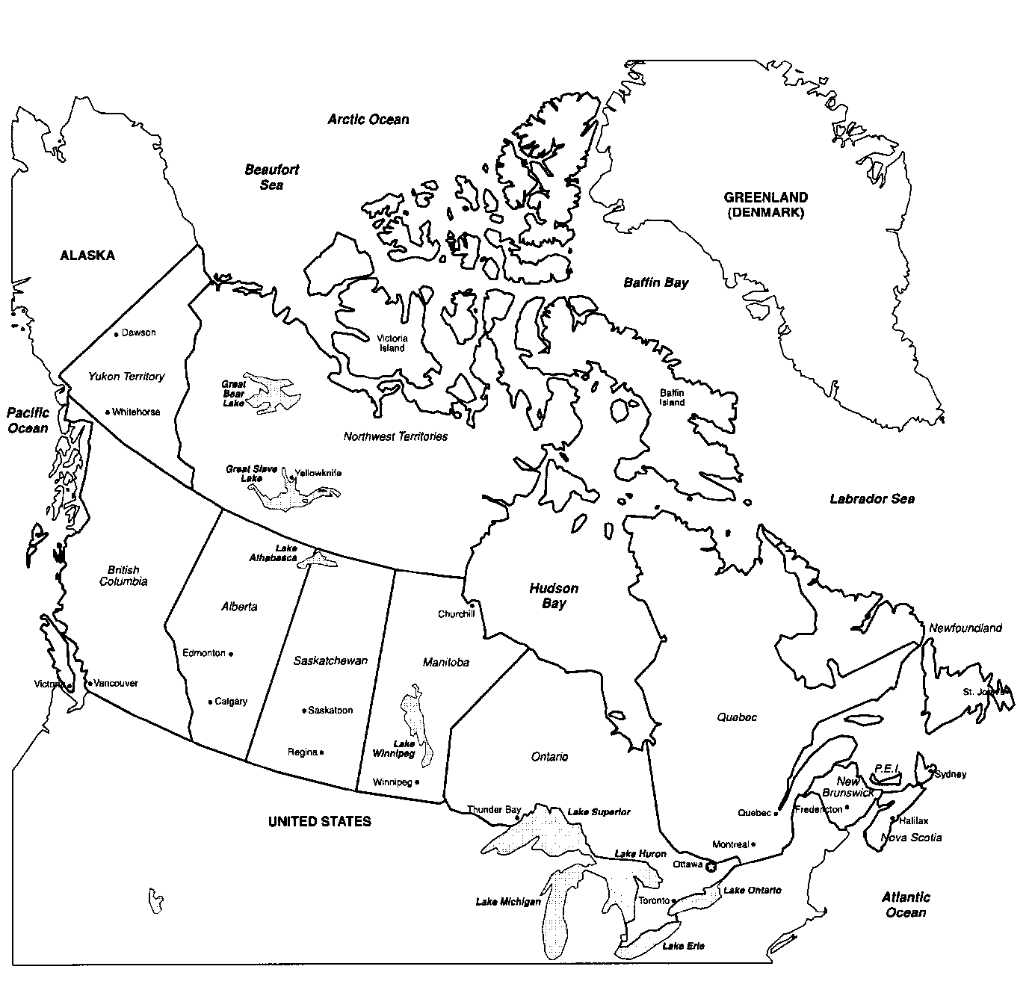
The Canadian Shield - ancient mountains; storehouse of minerals -gold, silver, zinc, copper, uranium (around Hudson Bay)

The Great Lakes - there live 50% of Canadians, the industrial heartland of Cnada, 70% of manufactured production is made here; production of maple sirup
(Southern Quebec and Ontario)

The Atlantic Provinces - there are wheat fields and also the richest fishing areas in the world
(Newfoundland, Nova Scotia, Prince Edward Island, New Brunswick)

The Arctic – now civilised land (roads, airports), short summers and long, bitterly cold winters

