15 THE POLITICS AND GOVERNMENT OF COMMONWEALTH COUNTRIES
broader view: prejudice and discrimination

- the Commonwealth is an association of 53 independent sovereign states, almost all of which are former territories of the British Empire, however it is not a political union of any sort
- Queen Elizabeth II is the Head of the Commonwealth; this title, however, does not imply any political power over member nations, and does not automatically belong to the British monarch
- while some fifteen nations of the Commonwealth, known as Commonwealth Realms, recognize the same person who is the British Monarch as their separate head of state, the majority do not
- it is primarily an organization in which countries with diverse economic backgrounds have an opportunity for close and equal interaction
- the primary activities of the Commonwealth are designed to create an atmosphere of economic co-operation between member nations, as well as the promotion of democracy, human rights, and good governance in those nations

CANADA
- it is a constitutional monarchy and a Commonwealth Realm that formally recognizes Elizabeth II as Queen of Canada
- a federal state, and parliamentary democracy with two official languages: French and English, and two systems of law:
      - civil law
      - common law
- the political system under which Canada operates is a Westminster system derived from the United Kingdom
- Canada's constitution governs the legal framework of the country and consists of written text and unwritten traditions and conventions
- 1982 – the Charter of Rights and Freedoms was entrenched in the Canadian Constitution

Federal government
- Canada has four main political parties today, the current government is formed by the Conservative Party of Canada

1. Legislative branch
- Parliament with the Queen represented by Governor General
- jointly the Parliament takes care of:
- national defense
- interprovincial and international trade and commerce
- immigration
- banking and monetary systém
- criminal law, …
- Senate = the Upper House
- 104 appointed members and divided among Canada’s four main territories (Ontario, Quebeck, West Provinces, Atlantic Provinces)
- it has pretty much the same powers as the House of Commons
- House of Commons – it’s the major lawmaking body
- 295 members who are elected in constituencies, five-year terms
- the leader of the majority party is asked to become Prime Minister
- Queen – represented by Governor General

2. Executive branch
Cabinet – under the direction of the Prime Minister
- however, officially, they should serve only as advisors to the
monarch

3. Judicial branch
- Canada’s laws are interpreted and applied by the courts
- each province is responsible for its own courts
- the federal Parliament has established a general court of appeal for Canada and a number of courts of specialized jurisdiction

Provinces and territories:
- 10 provinces (Alberta, British Columbia, Manitoba, New Brunswick, Newfoundland, Nova Scotia, Ontario, Prince Edward Island, Quebeck, Saskatchewan)
- 3 territories (Northwest Territories, Yukon Territory, Nunavut)
- the provinces have a large degree of autonomy from the federal government (provincial governments; premiere), the territories somewhat less
- each has its own provincial or territorial symbols
- although the territories occupy nearly 50 per cent of Canadian area they are very thinly inhabited by mainly native people – the density here is about 1 person in 65 sq km; this area is wild, full of mountains and tundra, ice-packs, giant lakes and subarctic bushland
- all provinces have unicameral, elected legislatures headed by a Premier selected in the same way as the Prime Minister of Canada
- each province also has a Lieutenant-Governor representing the Queen, analogous to the Governor General of Canada, appointed on the recommendation of the Prime Minister of Canada, though with increasing levels of consultation with provincial governments in recent years

National symbols:
- maple leaf – depicted on the current and flags, the penny, and on the coat of arms
- the anthem – “O Canada”, royal anthem – “God Save the Queen”
- the capital – Ottawa
- the biggest city - Toronto
- currency – Canadian dollar
- population – 32 million people

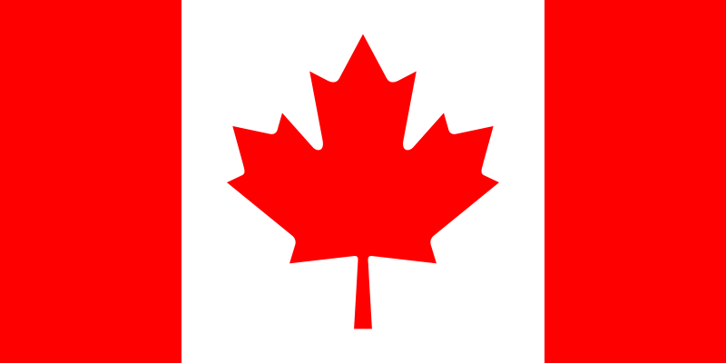

COMMONWEALTH OF AUSTRALIA
- the Commonwealth of Australia is a country in the Southern Hemisphere comprising the world's smallest continent and a number of islands in the Southern, Indian and Pacific Oceans
- it is a constitutional monarchy and has a parliamentary system of government
- Queen Elizabeth II is the Queen of Australia but she is nominally represented by the Governor-General at Federal level and by the Governors at State level
- The main political parties are the Liberal Party, the national Party (normally in coalition), the Australian Labor Party, and the Australian Democrats
- There’s comlupsory to vote!

Federal Government

1. Legislative branch – Parliament with the Queen
- banking and monetary system
- criminal law, …
- Senate
- elected, it has 76 members – they are elected by proportional
representation: 12 for each of the six states, 2 for the Australian
Capital territory and 2 for the Northern Territory
- senators serve for 6 years, elections are held every 3 years – half of
the Senate is renewed
- House of Representatives
- it has 148 members who are elected by universal adult suffrage for
3 years
- it is elected as single-member constituencies with preferential
voting
- Queen – represented by Governor General

2. Executive branch – Cabinet and the Federal Executive Council
- in practise, the councillors are the prime minister and ministers of state

3. Judicial branch
- the High Court of Australia and other federal courts

Administrative organization
- Australia is a federal state consisting of 6 states and 2 territories:
  - New South Wales (capital Sydney)
  - Victoria (capital Melbourne)
  - Queensland (Brisbane)
  - South Australia (Adelaide)
  - Western Australia (Perth)
  - Tasmania (Hobart)
- the Australian Capital Territory is a part of the country surrounding Australia’s capital Canberra, which has been chosen and built up as the capital of the whole country, the second territory is Northern Territory, which is thinly populated
- each state has its own constitution, governor, executive, legislative and judicial system

National symbols:
- national flag: blue field with the British Union Jack in the upper left corner, there are 5 stars arranged in the form of the Southern Cross constellation and the large white star under the British Union jack symbolizes 6 Australian states and 2 territories
- anthem: “Advance Australia Fair”
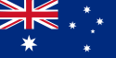
- capital: Canberra; biggest city: Sydney
- population: 20,5 million people
- currency: dollar

NEW ZEALAND
- it is a country in the south-western Pacific Ocean consisting of two large islands (called the North Island and South Island) and many much smaller islands
- it is a constitutional monarchy with a parliamentary democracy
- Queen Elizabeth II is Queen of New Zealand and is represented as head of state by the Governor-General
- New Zealand is the only country in the world in which all the highest offices in the land are occupied by women
- there is no single written constitution; however, the Constitution Act (1986) is the principal formal statement of New Zealand's constitutional structure
1. Legislative branch
Parliament has only one chamber, the House of Representatives, which seats 120 (or slightly more) members of Parliament - at least four of them are representatives of the Maori people
- the general elections are held every three years under a form of proportional representation
- the Governor-General has the power to appoint and dismiss Prime Ministers and to dissolve Parliament

2. Executive branch
Cabinet is the most senior policy-making body and is led by the Prime Minister, who is also the Parliamentary leader of the governing party or coalition
Executive Council is a formal committee consisting of all ministers of the Crown, members of the Executive Council are required to be Members of Parliament, and most are also in Cabinet

3. Judicial branch
Supreme Court of New Zealand is the highest court

Local Governments
- in addition to Central Government there are over 900 local authorities – that is local administrations directed by elected private citizens as in Britain; they have wide powers, and are elected by residents over 21

National Symbols
- the flag of New Zealand consists of the British Union Jack in the left upper corner and 4 red stars in the Southern Cross constellation
- anthem: “God Defend New Zealand“, “God Save the Queen“
- capital: Wellington
- biggest city: Auckland
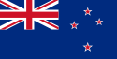
- population: 4 million people
- currency: New Zealand dollar

