17 THE POLITICS AND GOVERNMENT OF THE UNITED KINGDOM
broader view: appearance and personality

The single most important fact in understanding the nature of the British political system is that Britain has not been invaded or occupied for almost 1,000 years. The last successful invasion was in 1066 by the Normans.

This explains why:
- there was no revolution
- there is no written constitution (only has Bill of Rights)*
- the political system is not neat or logical
change has been very gradual and pragmatic and built on consensus
* The Labour Party (especially Gordon Brown) has gone further and called for a written constitution for the first time in Britain's history.
Great Britain – England (London) + Scotland (London ) + Wales (Cardiff)
United Kingdom – Great Britain + Northern Ireland (Belfast)
British Commonwealth of Nations - United Kongdom,Canada, Australia,
New Zealand and other territories

Britain is a parlamentary democracy with a constitutional monarch as a head of state, Britain’s democratic system of government is long established and well tried, and has provided remarkeble political stability which owes much to the monarchy. Its continuity has been interrupted only once in over thousand years when the republic of 1649-60 was formed after the defeat and execution of Charles I at the hands of Oliver Cromwell’s parlamentary army.

History
1215 – Magna Carta - a charter establishing the rights of English barons and free citizens, granted by King John at Runnymede in 1215 and regarded as the basis of civil and political liberty in England
The bicamerical nature of the British Parliament emerged in the 14th century and has served as a model in very many other parliamentary systems.
1628 – Petition of Right – a document produced by the English Parliament in the beginning of the English Civil War demanding from Charles I. enforcement of habeas corpus, no arrests contrary to the Magna Charta,…
1689 – the Bill of Rights – personal liberty/property cannot be taken without due process of law, no unreasonable searches and seizures,…

Constitution
Formed partly by statute, partly by common law and partly by convention
It can be altered by an Act of Parliament, or by general agreement to change a convention
Consists of multiple documents (see above), traditions and customs
Any law passed by the Parliament is constitutional

The Queen
The Queen (currently Queen Elizabeth II - acceded the throne in 1952) is impartial and acts on the advice of her ministers. She has „the right to be consulted, the right to encourage and the right to warn“. One important duty is the choice of Prime Minister, alhough by convention the monarch chooses the leader of the party with a majority in the House of Commons. She normally sees the Prime Minister each week as well as speaking to other ministers. She also receives copies of important government papers and a summary of debates in Parliament. Some duties are now largely ceremonial. A major exampleis the opening of Parliament each year by the Queen, when she delivers a speech from the throne setting out her Government’s plans for the coming year. The speech is prepares by the Government =o)

Parlimanet and Government
In the political system of the United States, the constitution provides that there must be a strict separate of powers of these three arms of government, so that no individual can be a member of more than one.

This is not the case in the UK:
- all Ministers in the government are members of the legislature
- some very senior judges sit in the upper house of the parliament
- the formal head of the judiciary is a senior minister

The Government is formed by the party with majority support in the Commons. The Queen appoints its leader as Prime Minister. The country in fact in governed by the Cabinet (about twenty leading ministers headed by Prime Minister). The second largest party forms the official Opposition, with its own leader and „shadow cabinet“. The Opposition has a duty to criticise government policies and to present an alternative programme.

Government Departments:
The most important political departments are called:
- The Treasury – In most countries, this would be called the Ministry of Finance.
- The Home Office - In most countries, this would be called the Ministry of the Interior.
- The Foreign and Commonwealth Office – In most countries, this would be called the Ministry of Foreign Affairs.

There are three main political parties in Britain:
- The Labour Party (often called New Labour) – the centre-Left party currently led by Gordon Brown (355, 55.0 %, 35.2 %)
- The Conservative Party (frequently called the Tories) – the centre-Right party currently led by David Cameron (198, 30.7 %, 32.4 %)
- The Liberal Democrat Party (known as the Lib Dems) – the centrist, libertarian party currently led by Menzies Campbell (62, 9.6 %, 22.0 %)

In the British political system, there is a broad consensus between the major parties on:
- the rule of law
- the free market economy
- the national health service
- UK membership of European Union and NATO

The main differences between the political parties concern:
- how to tackle poverty and inequality
- the levels and forms of taxation
- the extent of state intervention in the economy
- the balance between collective rights and individual rights

The supreme law-making body in the country is Parliament which consists of the House of Commons and the House of Lords. There are 650 electes Members of Parliament (MPs) in the House of Commons.

The House of Lords consists of hereditary and life peers and peeresses, the two archbishops (of Canterbury and York ) and 24 most senior bishops who are the representatives of the Church of England and Lord Chancellor. The centre of parliamentary power is the House of Lords as a revising chamber should complement the Commons and not rival it.

Election system:
Elections must be held at least every five years, but Prime minister can call the elections earlier, if he wants. Voting, which is not compulsory, is by secret ballot and it is from the age of 18.

The UK and Northern Ireland are divided into approximately 650 districts.
(523-England, 38-Wales, 72-Scotland, 17-N.Ireland)
Each district elects a single MP on a "First Past the Post" basis (i.e., you just need one more vote than the next guy, not an absolute majority). The leader of the party with the most MPs-elect is automatically appointed Prime Minister by the Queen, and appoints the balance of the cabinet from among other MPs and members of the House of Lords.
If the party with the most seats has a majority of seats, as has happens in most elections, the Prime Minister basically has carte blanche to run the country for the next five years (but customarily will call an election after only four years).
If it happens that the party with the most seats doesn't have a majority of seats, its leader is still appointed Prime Minister but is at risk of losing office (and being forced to call another election) if he can't attract the support of enough members of other parties to pass important legislation, or to survive a vote of "no confidence."

Symbols of the Country
- Flag – the Union Jack
- Anthem – “God Save the Queen!”
- Currency – pound sterling
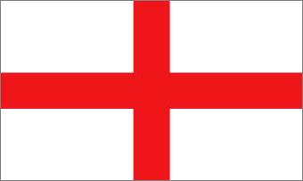
- England – St. George’s cross
red rose
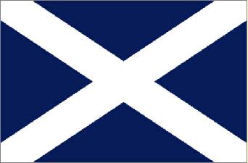
- Scotland – St. Andrew’s cross
thistle
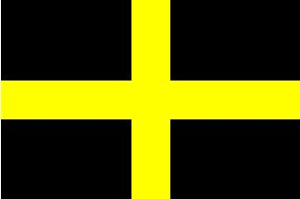
- Wales – St. David’s cross
leek and daffodil

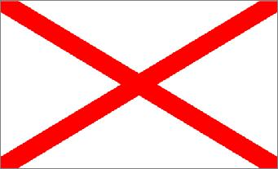
- N. Ireland – St. Patrick’s cross,
shamrock

